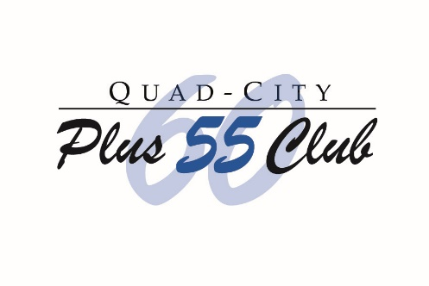
Quad-City Plus 60 Club Grant Application for FY 2020
Name of Organization___________________________________________________________
Street Address ____________________City_____________________ State_____Zip_________
Phone Number _____________________________Email_______________________________
Contact Person ________________________________Title _____________________________
++++++++++++++++++++++
Amount of Money Requested $________________
How will the money be used? Described the program in detail benefiting those 55 years and
older. (You may attach additional pages. Pictures are welcome.)
______________________________________________________________________________
______________________________________________________________________________________________________________________________________________________________________________________________________________________________________________________________________________________________________________________________________________________________________________________________________

Have you applied to the Plus 60 Club in the past three years? _____. If so, how many of those years did you receive funding? ___________
If grant money was received in 2019, a full detailed report must be submitted prior to applying for 2020 funding. Money must have been used for the program submitted and within the 2019 grant cycle, stating how the money was used and how many seniors benefitted.
Mail application to Plus 60 Community Outreach, PO Box 455, Bettendorf, Iowa 52722 or email it and any attachments to qcplus60@gmail.com . For additional information or questions, contact Plus 60 at qcplus60@gmail.com. Use “Community Outreach“ in the subject line. Applications will be carefully reviewed by the Plus 60 Board Community Outreach Committee. Funds are distributed in December and are for fiscal year 2020 only.

