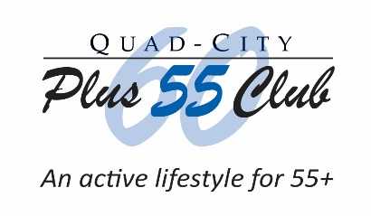
Quad-City Plus 60 Club Grant Application for FY 2021

[Please review the Grant Application Guidelines document before completing this form.]

Name of Organization: Click or tap here to enter Organization Name.
Street Address: Click or tap here to enter Street Address.
City, State & Zip Code: Click or tap here to enter City, State and Zip Code.

Contact Person: Click or tap here to enter Contact Person for this application.
Title: Click or tap here to enter Contact Person’s Title.
Daytime Phone: Click or tap here to enter Contact Person’s 999-999-9999 Phone #.
Email Address: Click or tap here to enter Contact Person’s Email Address.

Date of this Application: Click or tap to enter a date.

Amount of Money Requested for FY 2021? $Click or tap here to enter text.

Grant Application Request: How will the money be used? Describe the program in detail
benefiting those 55 years and older:

Click or tap here to enter text.

If you have a photo showing how the funds will be used, click an icon below to insert a photo:

Preparation Tip: When done, File Save As this application as “Plus 60 CO Grant Application for FY 2021 - Your Organization’s Name” on your computer.

A reminder to organizations that received a Plus 60 Club Community Outreach Grant last December for FY 2020: A program report must be received before being considered for future funding. Money must have been used for the program submitted and within the 2020 grant cycle, stating how the money was used and how many seniors benefited. The “CO Funded Report Form for 2019 Grants that funded FY 2020 Programs TEMPLATE” is available for your use on the Club’s website as a separate downloadable form for completion and submission to the Plus 60 Club.

Mail this FY 2021 Grant Application to Plus 60 Community Outreach, PO Box 455, Bettendorf, Iowa 52722-0008, postmarked by Friday, October 30, 2020.

Or, you can email your Grant Application and any attachments to qctimesplus60@gmail.com by Friday, October 30, 2020. Please type “Community Outreach Application” in the subject line.

Applications will be carefully reviewed by the Plus 60 Board Community Outreach Committee. Funds are distributed in December and are for fiscal year 2021 only.

For additional information or questions, contact Plus 60 at qctimesplus60@gmail.com. Please type “Community Outreach Inquiry” in the subject line.

