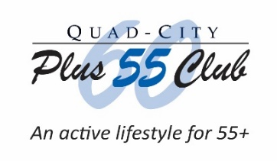
Quad-City Plus 60 Club Community Outreach Report for
Funds Received in December 2021 for use in 2022

A program report must be submitted before being considered for future funding.

Date of this Report: Click or tap to enter a date.

Name of Organization: Click or tap here to enter Organization Name.
Street Address: Click or tap here to enter Street Address.
City, State & Zip Code: Click or tap here to enter City, State and Zip Code.

Contact Person: Click or tap here to enter Contact Person for this report.
Title: Click or tap here to enter Contact Person’s Title.
Daytime Phone: Click or tap here to enter Contact Person’s 999-999-9999 Phone #.
Email Address: Click or tap here to enter Contact Person’s Email Address.

Amount of money received in DEC. 2021 for 2022 Program? $ Click or tap here to enter text.

Name of senior program funded? Click or tap here to enter text.

Objectives for this senior program:

Click or tap here to enter text.

State how many seniors age 55 and above were served: Click or tap here to enter text.

Please describe in detail how the funds were used:

Click or tap here to enter text.

If you have a photo showing how the funds were used, click an icon below to insert a photo:

Preparation Tip: When done, ‘File Save As’ this report as “CO Funded 2022 Program Report - Your Organization’s Name” on your computer.

When you finish completing this report, save it as a Word document file to your computer for viewing, printing and mailing to the Quad-City Plus 60 Club, or submitting as a file attachment sent via email to the Club.

- Mail this end-of-year or end-of program report to Plus 60 Community Outreach, PO Box 455, Bettendorf, Iowa 52722-0008 or

- Submit this completed report by file attachment to an email sent to the Club at qctimesplus60@gmail.com. Please type “Community Outreach” in the subject line.

For additional information or questions, contact Plus 60 at qctimesplus60@gmail.com. Please type “Community Outreach Inquiry” in the subject line.

