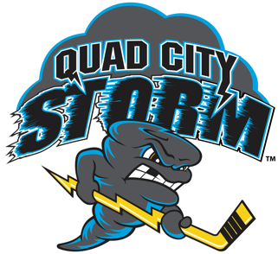Hockey? Fun? YES! Quad City Storm Hockey team is at it again. Entertaining the crowds as well as raising money for local charities. Last season the Storm Hockey Team raised over $163,000 for local charities.
Last year the Plus 60(55) group that attended had so much fun that we are going again this year! This is an outing you won’t want to miss! Young and old alike – bring your family, grandkids and friends! Visit the free Kids’ Fun Zone. From the time you arrive until the time you leave, you will be cheering for the hometown’s hockey team – the Quad City Storm!
Sunday, January 26th@1:00 p.m. It is MARGARITAVILLE Senior Day! Enjoy a Margarita that will be sold in the arena. Doors open at noon.
$15 seats for ONLY $10; Section 107 Rows 14-20+; Elevator Access Handicap Accessible-Need to Call Joe Kazmier@309-277-1330 for arrangements
Lucky Plus 60 members have a chance to win a wine basket Compliments of Plus 60(55). Anyone wanting a locker room tour, you are to meet Joe and Susie Stark at the fan services table (located behind section 109) at 12:15 pm right before pre-game warmups.
You may buy your tickets by mailing your registration form and your check
payable to PLUS 60. MAIL TO:
Plus 60 Hockey Event
4 Aspen Drive
Blue Grass, IA. 52726
All registrations MUST be postmarked by TUESDAY, JANUARY 21,2020 !
If you want to sit by certain friends then registration forms must be sent together.
Absolutely NO REFUNDS! Questions? Call: 563-320-5052
You will pick up your tickets at Will Call the day of the game.
Let’s Have Some Fun!!
